Assignment 1

Name : Mohamed Khaled Ahmed atyaa

Group num : 3

Id : 16

Ques 1

**Describe in details Linux root file system ?**

**/ (Root):**Primary hierarchy root and root directory of the entire file system hierarchy.

**/bin :**Essential command binaries that need to be available in single-user mode

**/boot :**Boot loader files, e.g., kernels

**/dev :**Essential device files,

**/etc :**Host-specific system-wide configuration files

**/home :**Users’ home directories, containing saved files, personal settings, etc

**/lib :**Libraries essential for the binaries in /bin/ and /sbin/

**/media :**Mount points for removable media such as CD-ROMs

**/mnt :**Temporarily mounted filesystems

**/opt :**Optional application software packages

**/sbin :**Essential system binaries

**/srv :**Site-specific data served by this system, such as data and scripts for web servers, data offered by FTP servers, and repositories for version control systems

**/tmp :**Temporary files. Often not preserved between system reboots, and may be severely size restricted.

**/usr :**Secondary hierarchy for read-only user data; contains the majority of (multi-)user utilities and applications.

**/proc :**Virtual filesystem providing process and kernel information as files. In Linux, corresponds to a procfs mount. Generally automatically generated and populated by the system, on the fly.

Ques 2

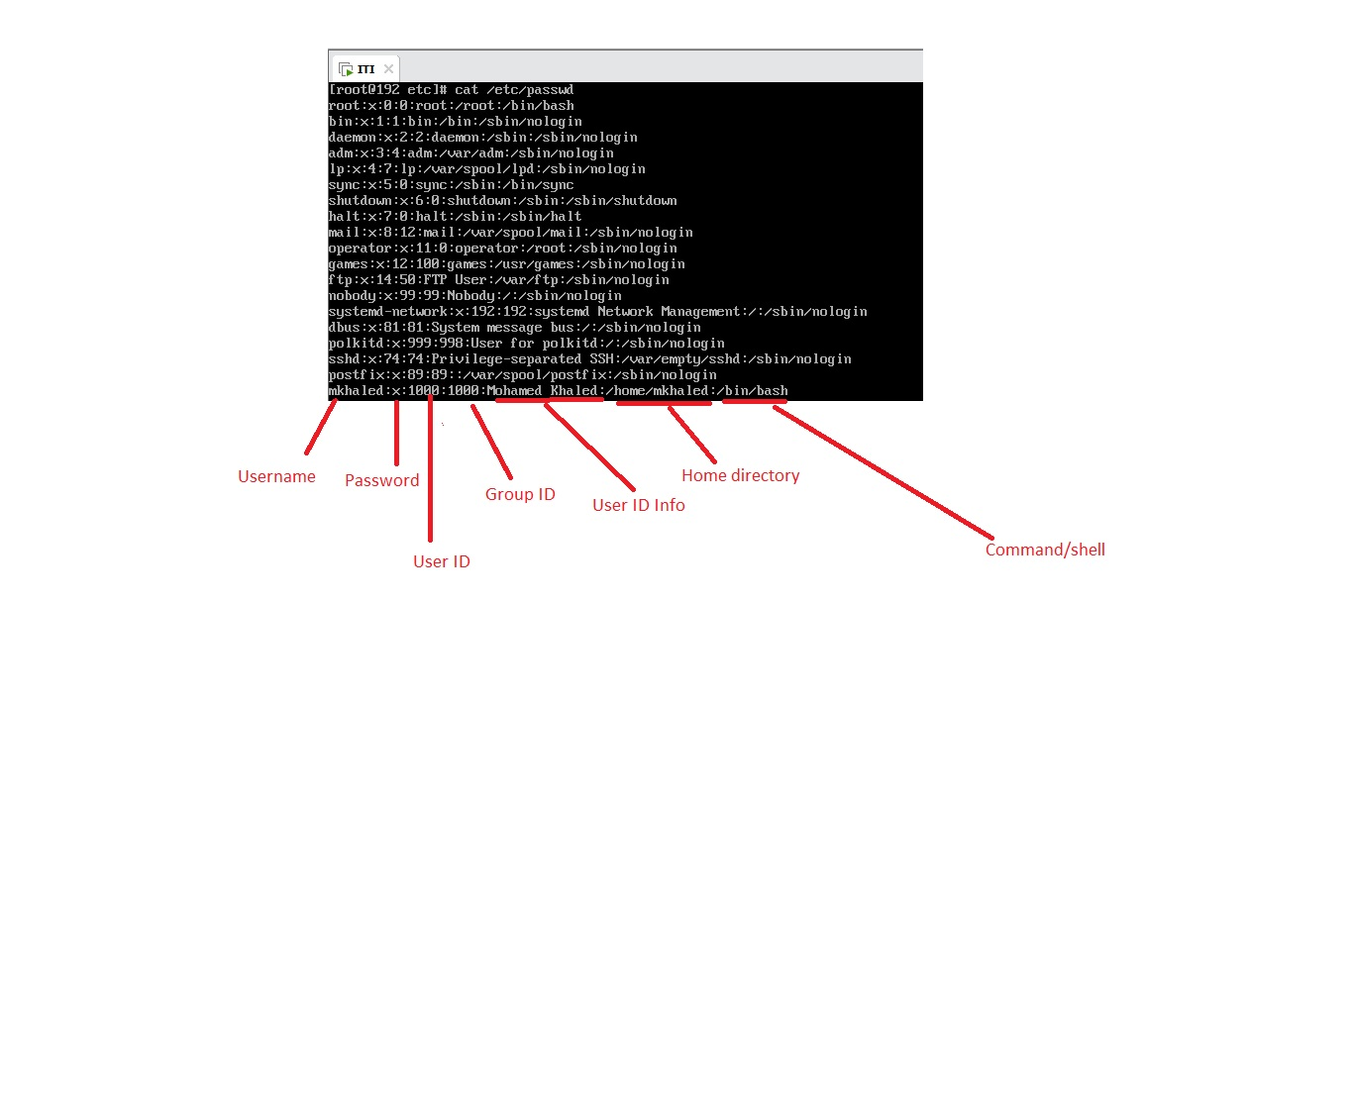**Describe in details etc/passwd file?**